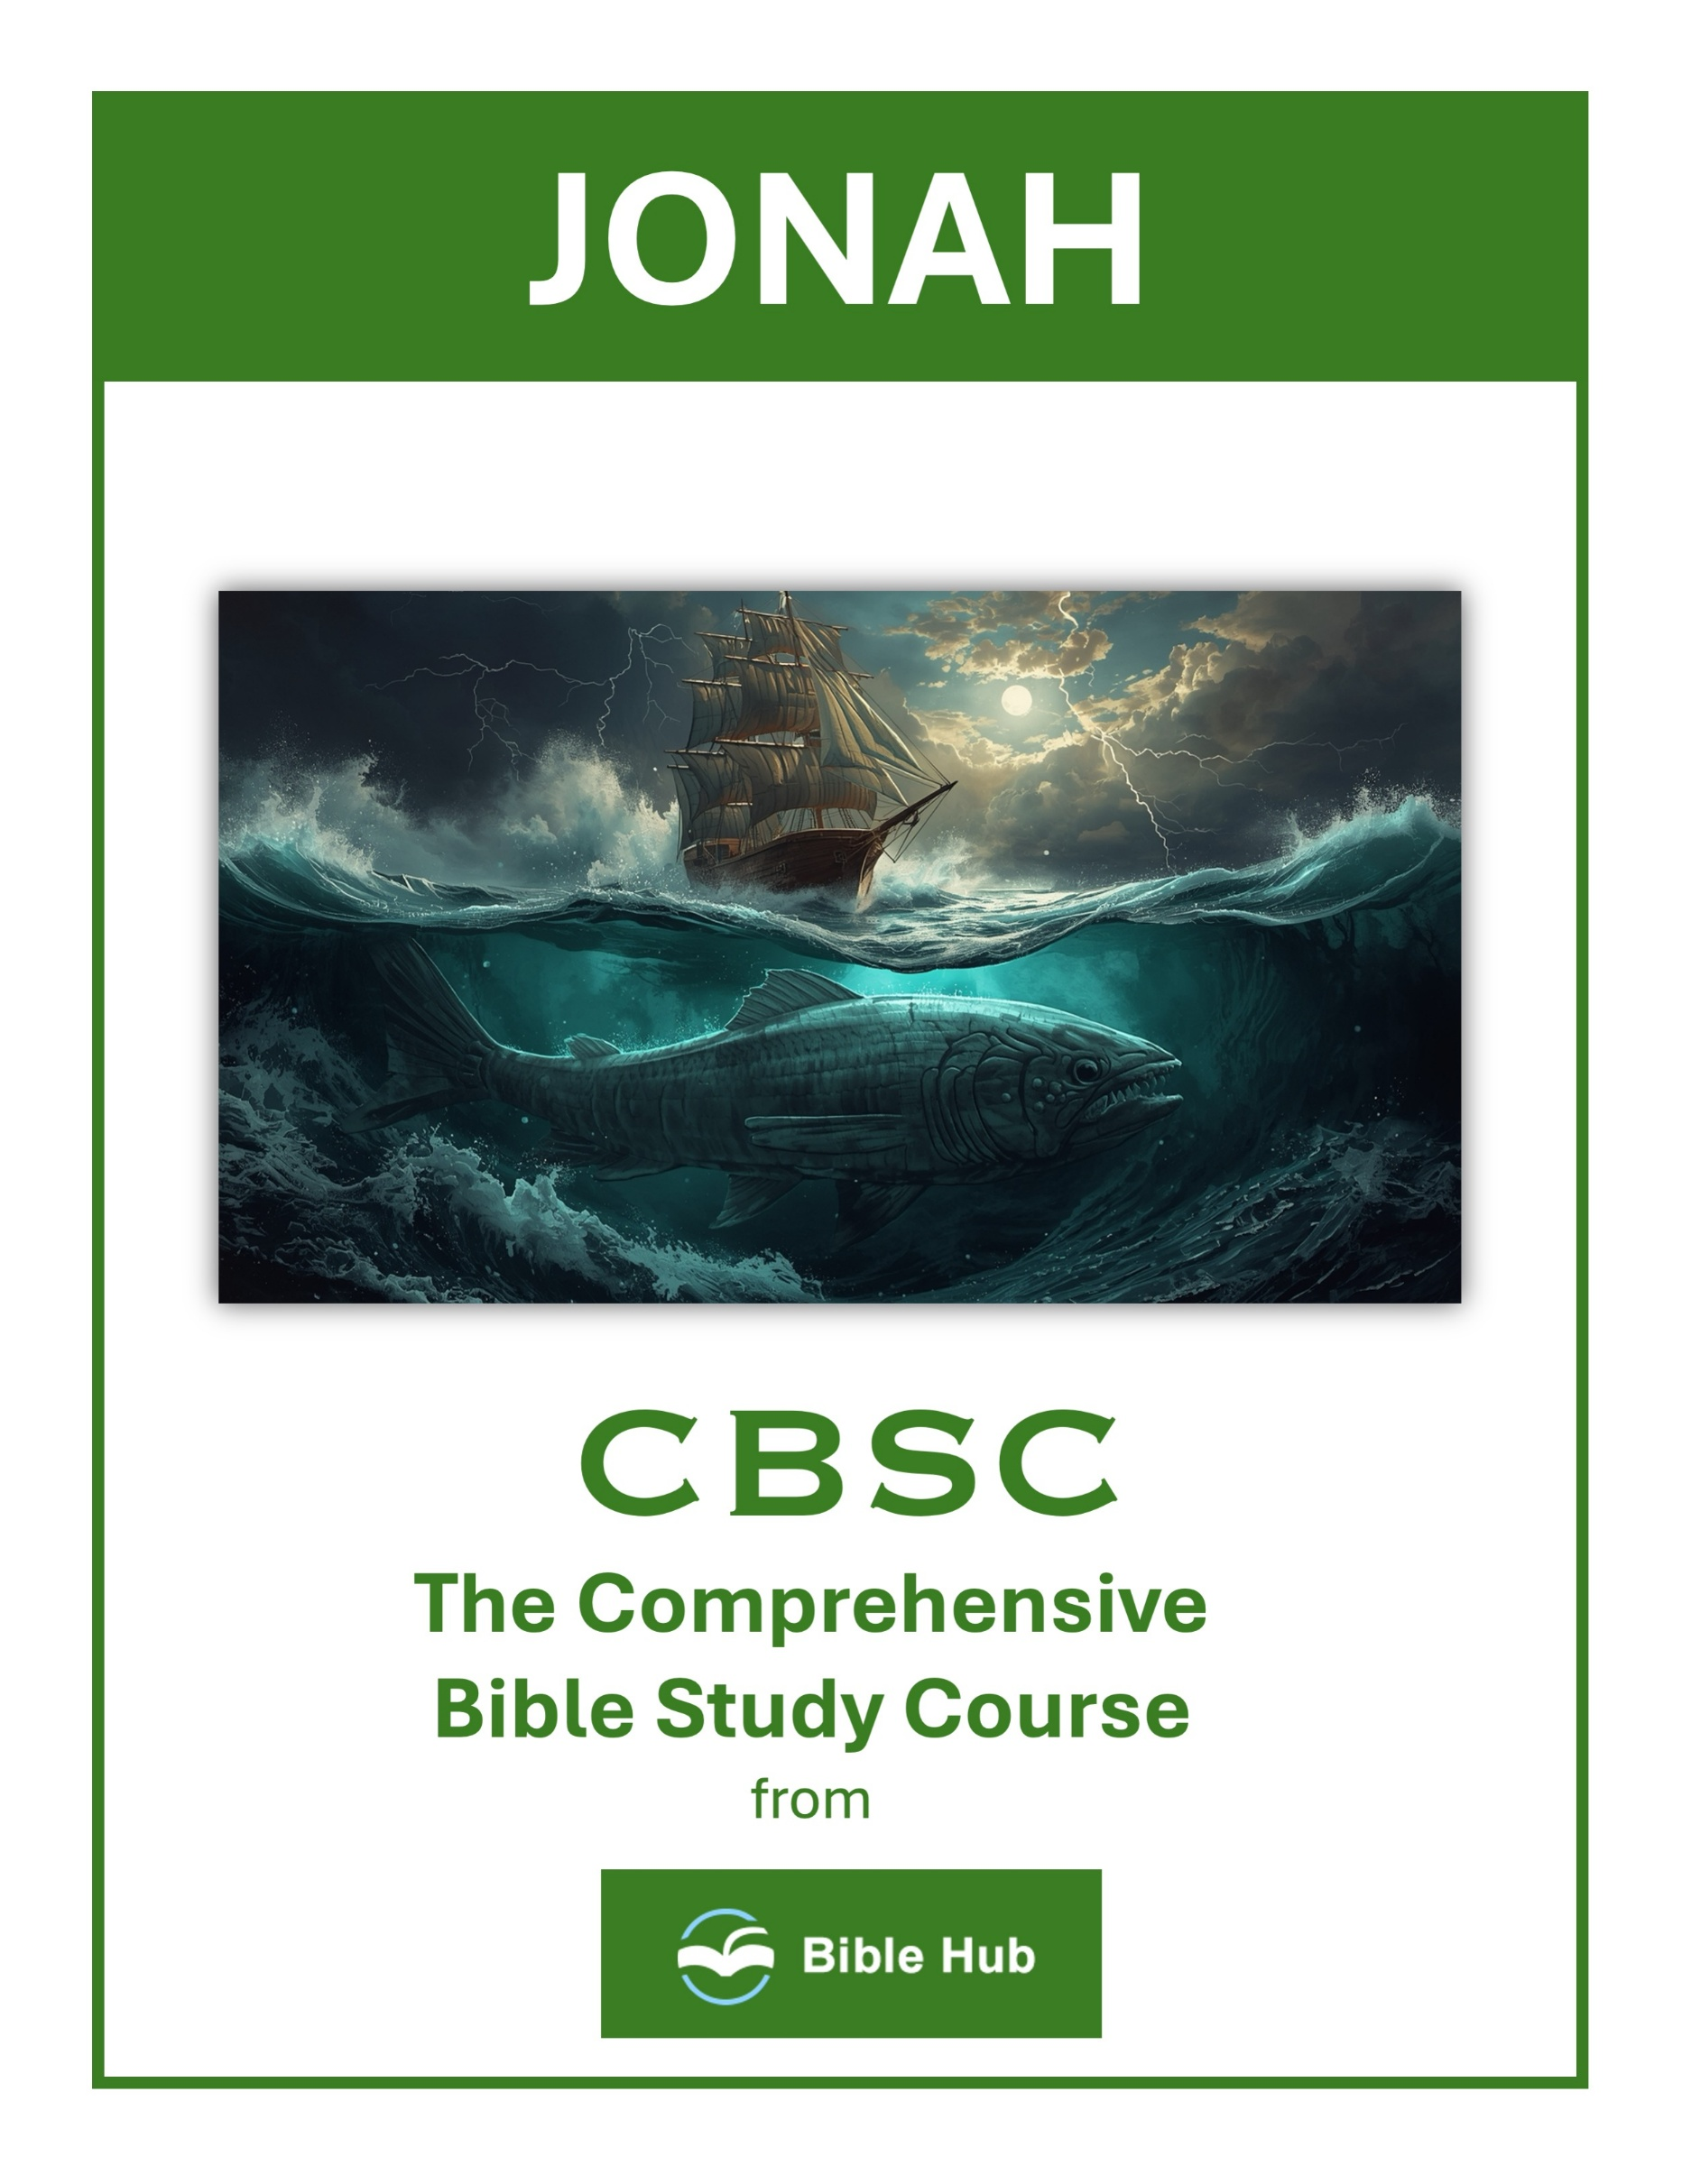

Jonah 1 Teaching Points and Bible Study Questions
You Can’t Run from God’s Call
Jonah’s story begins with a clear directive from God: “Arise, go to Nineveh, that great city, and cry out against it” (Jonah 1:2). Yet, Jonah attempts to flee from the presence of the Lord. This teaches us that no matter how far we try to run, God’s call on our lives is inescapable. Embrace His purpose for you, knowing that His plans are always for your good and His glory.
1. How can you identify and respond to God's call in your daily life?
2. Why do you think people often try to avoid God's call, and how can you overcome this?
3. What steps can you take to align your actions with God's purpose for you?
Disobedience Has Consequences
When Jonah boarded a ship to Tarshish, he wasn’t just running away; he was inviting trouble. “But the LORD hurled a great wind upon the sea, and such a violent storm arose that the ship was in danger of breaking apart” (Jonah 1:4). Our choices have consequences, and disobedience can lead to storms in our lives. It’s a reminder to align our actions with God’s will.
1. How can you identify and address areas of disobedience in your life to avoid negative consequences?
2. Why do you think people often choose disobedience despite knowing potential consequences?
3. What can you learn from Jonah's experience to help you make better choices in difficult situations?

God’s Sovereignty Over Nature
The storm that threatened Jonah’s ship was no ordinary squall; it was divinely orchestrated. This demonstrates God’s sovereignty over all creation. “The sea was growing more and more tempestuous” (Jonah 1:11). Recognize that God can use even the forces of nature to guide us back to Him and His purposes.
1. How can recognizing God's control over nature influence your response to life's storms?
2. Why do you think God used a storm to redirect Jonah, and how might He redirect you?
3. What can you learn from Jonah about trusting God's sovereignty in uncertain situations?
The Power of Prayer in Crisis
In the midst of the storm, the sailors cried out to their gods, but it was Jonah’s God who had the power to save. “Then the men feared the LORD greatly, and they offered a sacrifice to the LORD and made vows to Him” (Jonah 1:16). When faced with life’s tempests, turn to prayer, knowing that God hears and responds to the cries of His people.
1. How can you incorporate prayer into your response during personal crises, like Jonah's situation in the storm?
2. Why do you think prayer was a turning point for Jonah and the sailors in their crisis?
3. What can you learn from Jonah's experience about the impact of prayer in desperate situations?

God’s Mercy Extends to All
Jonah’s reluctance to preach to Nineveh stemmed from his desire to see them punished. Yet, God’s mercy knows no bounds. “Should I not have concern for the great city of Nineveh?” (Jonah 4:11). This lesson reminds us that God’s love and mercy extend to all people, regardless of their past.
1. How can you show mercy to those you initially resist helping, like Jonah with the Ninevites?
2. Why do you think God extends mercy to those we might consider undeserving?
3. What can you learn from Jonah about accepting God's call to show mercy to all?
Repentance Leads to Redemption
When Jonah finally obeyed and preached to Nineveh, the city repented. “The people of Nineveh believed God. They proclaimed a fast and dressed in sackcloth” (Jonah 3:5). True repentance leads to redemption and transformation. It’s never too late to turn back to God and experience His forgiveness.
1. How can recognizing personal mistakes lead to meaningful change in your life, like Jonah's experience?
2. What steps can you take to seek redemption when you realize you've strayed from your path?
3. Why do you think acknowledging wrongdoing is crucial for personal growth and redemption?

God’s Patience with Our Imperfections
Jonah’s journey is marked by reluctance and anger, yet God patiently guides him. “But Jonah was greatly displeased and became angry” (Jonah 4:1). God’s patience with Jonah is a testament to His understanding of our human frailties. He works with us, even when we falter, to fulfill His purposes.
1. How can you recognize and respond to God's patience in your own moments of imperfection?
2. Why do you think God shows patience despite Jonah's disobedience, and how does this apply to you?
3. What can you learn from Jonah's story about handling your own reluctance to follow God's guidance?
The Importance of Compassion
Jonah’s lack of compassion for Nineveh contrasts with God’s heart for the lost. “And should I not have concern for the great city of Nineveh?” (Jonah 4:11). We are called to reflect God’s compassion in our interactions with others, extending grace and love to those who need it most.
1. How can you show compassion to those who seem undeserving, like Jonah was called to do for Nineveh?
2. Why do you think Jonah struggled with compassion, and how can you overcome similar feelings?
3. What can you learn from Jonah's experience about the impact of withholding compassion on others and yourself?

God’s Lessons in Unexpected Places
Jonah’s time in the belly of the great fish was a turning point. “From inside the fish, Jonah prayed to the LORD his God” (Jonah 2:1). Sometimes, God places us in unexpected situations to teach us valuable lessons. Embrace these moments as opportunities for growth and deeper understanding.
1. How can you recognize and embrace God's lessons in unexpected situations in your daily life?
2. Why do you think God uses unexpected places to teach us important lessons?
3. What can you learn from Jonah's experience about trusting God's plan in unfamiliar circumstances?
The Unfathomable Depth of God’s Love
Ultimately, Jonah’s story is a testament to the depth of God’s love for humanity. Despite Jonah’s failings, God’s love for Nineveh and for Jonah himself never wavered. “For You, LORD, are good, and ready to forgive, and abundant in loving devotion to all who call on You” (Psalm 86:5). Let this truth inspire you to trust in God’s unwavering love and to share it with the world.
1. How can you demonstrate God's unfathomable love to those who seem undeserving, like Jonah with Nineveh?
2. Why do you think God pursued Jonah despite his disobedience, and how does this reflect His love?
3. What can you learn from God's patience with Jonah about showing love to difficult people in your life?

Jonah 2 Teaching Points and Bible Study Questions
The Power of Prayer in Desperation
When Jonah found himself in the belly of the great fish, he turned to prayer. In Jonah 2:1, it says, "From inside the fish, Jonah prayed to the LORD his God." This teaches us that no matter how dire our circumstances, prayer is a powerful tool. It connects us to God, who is always ready to listen and respond. When life feels overwhelming, remember that God is just a prayer away.
1. How can Jonah's prayer in desperation inspire your own prayers during challenging times?
2. What do you hope to gain from praying when feeling overwhelmed or trapped?
3. Why does turning to prayer in desperation often lead to personal transformation?
God's Presence in Our Darkest Moments
Jonah's experience in the depths of the sea reminds us that God is with us even in our darkest moments. Jonah 2:2 states, "In my distress I called to the LORD, and He answered me. From the belly of Sheol I called for help, and You heard my voice." This is a comforting reminder that no matter how far we feel from God, He is always near, ready to hear our cries and offer His presence.
1. How can you recognize God's presence when facing your own "belly of the fish" moments?
2. Why do you think Jonah's prayer in darkness can inspire hope in your struggles?
3. What practical steps can you take to seek God's presence during life's challenges?

Acknowledging God's Sovereignty
Jonah recognized God's hand in his situation, acknowledging that it was God who cast him into the deep. Jonah 2:3 says, "For You cast me into the deep, into the heart of the seas, and the current swirled about me." This teaches us to see God's sovereignty in every aspect of our lives, trusting that He is in control, even when we don't understand His ways.
1. How can acknowledging God's sovereignty in difficult times change your perspective and actions today?
2. Why do you think recognizing God's control can lead to personal peace and trust in challenging situations?
3. What can you do daily to remind yourself of God's sovereignty in your life decisions?
The Importance of Repentance
Jonah's prayer is filled with repentance and a turning back to God. In Jonah 2:4, he says, "I have been banished from Your sight, yet I will look once more toward Your holy temple." This shows us the importance of repentance in our relationship with God. When we stray, turning back to Him with a repentant heart restores our fellowship with Him.
1. How can Jonah's prayer in the fish inspire your personal approach to repentance today?
2. Why do you think acknowledging past mistakes is crucial for genuine repentance and growth?
3. What steps can you take to ensure your repentance leads to lasting change in your life?

God's Mercy and Grace
Despite Jonah's disobedience, God showed him mercy. Jonah 2:6 reveals, "To the roots of the mountains I descended; the earth beneath me barred me in forever! But You raised my life from the pit, O LORD my God." This is a powerful reminder of God's grace, which is available to us no matter how far we have fallen. His mercy is new every morning.
1. How can you recognize and respond to God's mercy in difficult situations like Jonah did in the fish?
2. Why do you think acknowledging God's grace is crucial when facing personal challenges or failures?
3. What can you learn from Jonah's prayer about seeking God's mercy in times of distress?
The Futility of Idolatry
Jonah 2:8 warns, "Those who cling to worthless idols forsake His loving devotion." This verse highlights the futility of idolatry and the importance of worshiping the one true God. When we place anything above God, we miss out on His steadfast love and faithfulness. Let us keep our focus on Him, who alone is worthy of our devotion.
1. How can recognizing the futility of idolatry change your daily priorities and decisions?
2. Why do you think people often turn to idols instead of seeking God's help?
3. What practical steps can you take to identify and remove idols in your life?

Salvation Belongs to the Lord
Jonah's declaration in Jonah 2:9, "Salvation comes from the LORD," is a profound truth. It reminds us that our salvation is not something we can earn or achieve on our own. It is a gift from God, made possible through the death and resurrection of Jesus Christ. Trust in Him for your salvation, for He is the only way.
1. How can recognizing "Salvation Belongs to the Lord" change your response to life's challenges today?
2. Why do you think acknowledging God's control over salvation impacts your trust in difficult situations?
3. What can you do daily to remind yourself that salvation is ultimately God's responsibility, not yours?
Gratitude in All Circumstances
Even in the belly of the fish, Jonah expressed gratitude. Jonah 2:9 says, "But I, with shouts of grateful praise, will sacrifice to You." This teaches us to cultivate a heart of gratitude, regardless of our circumstances. When we focus on God's goodness and faithfulness, our perspective shifts, and we find joy even in trials.
1. How can you express gratitude during challenging times, like Jonah did from inside the fish?
2. Why do you think gratitude is important even when circumstances seem dire?
3. What can you learn from Jonah's prayer about maintaining a thankful heart in adversity?

The Transformative Power of Obedience
Jonah's experience led to a renewed commitment to obey God. Jonah 2:9 concludes with, "What I have vowed I will make good." This highlights the transformative power of obedience. When we align our lives with God's will, we experience His blessings and purpose. Let us strive to obey Him wholeheartedly.
1. How can Jonah's prayer in the fish inspire your own obedience during challenging times?
2. What do you hope to transform in your life through obedience to God's call?
3. Why does obedience often lead to personal growth and transformation, as seen in Jonah's experience?
God's Faithfulness to His Promises
Finally, Jonah's deliverance from the fish demonstrates God's faithfulness. Jonah 2:10 says, "And the LORD commanded the fish, and it vomited Jonah onto dry land." God kept His promise to deliver Jonah, just as He keeps His promises to us. Trust in His faithfulness, for He is the same yesterday, today, and forever.
1. How can you trust God's faithfulness when facing overwhelming situations like Jonah in the fish?
2. Why do you think Jonah's prayer reflects confidence in God's promises despite his dire circumstances?
3. What can you do to remember God's faithfulness during personal challenges or moments of doubt?

Jonah 3 Teaching Points and Bible Study Questions
God’s Mercy is Boundless
In Jonah 3, we see a powerful demonstration of God's mercy. Despite Nineveh's wickedness, God offers them a chance to repent. This reminds us that "The LORD is compassionate and gracious, slow to anger, abounding in loving devotion" (Psalm 103:8). No matter how far we stray, God’s mercy is always within reach.
1. How can you demonstrate God's boundless mercy in your daily interactions with others?
2. Why do you think God’s mercy is important in fostering forgiveness and reconciliation?
3. What can you learn from Jonah 3 about extending mercy to those who have wronged you?
Obedience Leads to Transformation
When Jonah finally obeys God’s command to go to Nineveh, the entire city is transformed. This teaches us that our obedience to God can have a ripple effect, impacting not just our lives but also the lives of those around us. As James 1:22 says, "Be doers of the word, and not hearers only."
1. How can personal obedience to God's call lead to transformation in your community today?
2. What do you hope to change in your life by obeying God's guidance like Jonah did?
3. Why does obedience often result in unexpected positive outcomes, as seen in Nineveh's transformation?

God Uses Imperfect People
Jonah was reluctant and flawed, yet God used him to bring about a great revival. This is a comforting reminder that God can use anyone, regardless of their past or imperfections, to fulfill His purposes. As 2 Corinthians 12:9 states, "My grace is sufficient for you, for My power is perfected in weakness."
1. How can you embrace your imperfections to fulfill God's purpose, like Jonah did in Nineveh?
2. Why do you think God chooses imperfect people for His missions, as seen with Jonah?
3. What can you learn from Jonah's story about accepting second chances in your own life?
Repentance is Powerful
The people of Nineveh believed God and turned from their evil ways, leading to their salvation. This highlights the power of genuine repentance. "If we confess our sins, He is faithful and just to forgive us our sins and to cleanse us from all unrighteousness" (1 John 1:9).
1. How can you incorporate repentance into your daily life to foster personal growth and transformation?
2. Why do you think genuine repentance can lead to positive change in relationships and communities?
3. What steps can you take to ensure your repentance is sincere and impactful?

God’s Word is Effective
Jonah’s message was simple, yet it was effective because it was God’s word. This reminds us that the power lies not in our eloquence but in the truth of God’s message. "So is My word that goes out from My mouth: It will not return to Me empty" (Isaiah 55:11).
1. How can you apply God's effective word in your daily decision-making processes?
2. Why do you think God's word prompted such a strong response from the Ninevites?
3. What can you do to ensure you are receptive to God's word in your life?
God’s Patience is a Gift
God’s willingness to give Nineveh a second chance shows His incredible patience. This patience is a gift, allowing us time to turn back to Him. "The Lord is not slow in keeping His promise, as some understand slowness, but is patient with you" (2 Peter 3:9).
1. How can you recognize and appreciate God's patience in your daily life decisions?
2. What steps can you take to extend patience to others as God does with you?
3. Why do you think God’s patience is essential for personal growth and transformation?

Humility Opens Doors
The king of Nineveh humbled himself, leading his people in repentance. Humility is key to opening the door to God’s grace. "Humble yourselves before the Lord, and He will exalt you" (James 4:10).
1. How can practicing humility in your daily life open doors for personal growth and new opportunities?
2. Why do you think humility was crucial for Nineveh's transformation and how can it apply to us today?
3. What would you do differently if you believed humility could change your current challenging situation?
God’s Plans are Unstoppable
Despite Jonah’s initial disobedience, God’s plan for Nineveh was fulfilled. This reassures us that God’s plans are unstoppable, and His purposes will prevail. "The counsel of the LORD stands forever, the purposes of His heart to all generations" (Psalm 33:11).
1. How can you align your actions with God's unstoppable plans in your daily life?
2. Why do you think God's plans prevailed despite Jonah's initial reluctance?
3. What can you learn from Nineveh's response to God's warning about embracing change?

Faith Can Move Cities
The faith of the Ninevites in God’s warning led to their city being spared. This illustrates the power of faith to bring about change. "For we walk by faith, not by sight" (2 Corinthians 5:7).
1. How can your personal faith inspire change in your community like Jonah's message did in Nineveh?
2. What steps can you take to encourage collective faith in your city or neighborhood?
3. Why do you think faith was pivotal in transforming Nineveh, and how can this apply today?
God Desires Salvation for All
Ultimately, Jonah 3 reveals God’s heart for all people to be saved. His desire is for everyone to come to repentance and experience His love. "He wants everyone to be saved and to come to the knowledge of the truth" (1 Timothy 2:4).
These lessons from Jonah 3 remind us of the depth of God’s love and the transformative power of His word. Let’s embrace these truths and allow them to guide our lives.
1. How can you actively participate in sharing God's message of salvation with those around you?
2. Why do you think God desires salvation for everyone, even those we might consider undeserving?
3. What steps can you take to cultivate a heart that rejoices in others' salvation?

Jonah 4 Teaching Points and Bible Study Questions
God’s Compassion Knows No Bounds
In Jonah 4, we see a God whose compassion extends beyond what we might expect. Jonah was displeased with God’s mercy towards Nineveh, but God’s response reminds us that His love is vast and inclusive. As it says in Jonah 4:11, "Should I not have concern for the great city of Nineveh, in which there are more than a hundred and twenty thousand people who cannot tell their right hand from their left?" This teaches us that God’s compassion is not limited by our understanding or preferences.
1. How can you show compassion to those you struggle to understand or disagree with?
2. Why do you think God’s compassion extends to those we might deem undeserving?
3. What can you learn from Jonah’s reaction to God’s compassion towards Nineveh?
The Danger of Self-Righteousness
Jonah’s anger at God’s mercy towards Nineveh highlights the danger of self-righteousness. Jonah was more concerned with his own sense of justice than with God’s plan. This serves as a reminder to examine our hearts and align our desires with God’s will, as Proverbs 21:2 reminds us, "Every way of a man is right in his own eyes, but the LORD weighs the heart."
1. How can you recognize and address self-righteous attitudes in your daily interactions with others?
2. Why do you think self-righteousness can hinder compassion and understanding towards those who differ from you?
3. What steps can you take to ensure humility and empathy guide your responses to others' mistakes?

God’s Patience with Our Imperfections
Despite Jonah’s anger and stubbornness, God patiently engages with him. This patience is a testament to God’s enduring love and willingness to guide us even when we falter. As 2 Peter 3:9 states, "The Lord is not slow in keeping His promise, as some understand slowness. Instead, He is patient with you, not wanting anyone to perish, but everyone to come to repentance."
1. How can you practice patience with others' imperfections, as God did with Jonah's anger?
2. Why do you think God showed patience with Jonah despite his repeated complaints?
3. What can you learn from God's patience with Jonah to apply in your own relationships?
The Importance of Perspective
Jonah’s limited perspective led him to question God’s actions. God uses a plant to teach Jonah about perspective, showing him that his concern for the plant should mirror his concern for the people of Nineveh. This lesson encourages us to seek God’s perspective in our lives, as Isaiah 55:8-9 reminds us, "For My thoughts are not your thoughts, neither are your ways My ways."
1. How can shifting your perspective help you respond to situations with more compassion, like Jonah with Nineveh?
2. Why do you think Jonah struggled with God's perspective on mercy, and how can you avoid similar pitfalls?
3. What can you learn from Jonah's experience to better align your perspective with God's in challenging times?

The Value of All Creation
God’s concern for Nineveh extends to the animals within the city, highlighting the value of all creation. This reflects the truth that God cares for every part of His creation, as seen in Matthew 10:29, "Are not two sparrows sold for a penny? Yet not one of them will fall to the ground outside your Father’s care."
1. How can you show compassion to all of creation in your daily life like God did with Nineveh?
2. Why do you think God values every part of creation, and how can this influence your actions?
3. What steps can you take to appreciate and protect the environment and creatures around you?
The Power of Repentance
Nineveh’s repentance led to God’s mercy, demonstrating the transformative power of turning away from sin. This is a powerful reminder that repentance is a key step in our relationship with God, as Acts 3:19 encourages, "Repent, then, and turn to God, so that your sins may be wiped out."
1. How can Jonah's reaction to Nineveh's repentance inform your response to others seeking forgiveness today?
2. Why do you think God values repentance over punishment, and how can this shape your interactions?
3. What can you learn from Jonah's experience about embracing change in those who genuinely repent?

God’s Sovereignty Over Nature
The plant, the worm, and the scorching wind in Jonah 4 illustrate God’s control over nature. This sovereignty reassures us that God is in control of all circumstances, as Psalm 24:1 declares, "The earth is the LORD’s, and everything in it, the world, and all who live in it."
1. How can you recognize God's sovereignty in nature during challenging times in your life?
2. Why do you think God uses nature to teach Jonah about compassion and patience?
3. What can you learn from Jonah's experience about trusting God's control over natural events?
The Call to Love Our Enemies
Jonah’s reluctance to see Nineveh spared challenges us to love our enemies and desire their salvation. Jesus echoes this in Matthew 5:44, "But I tell you, love your enemies and pray for those who persecute you." This call to love is central to living out our faith.
1. How can you show love to someone you struggle to forgive, like Jonah with Nineveh?
2. Why do you think it's challenging to love those who oppose us, as Jonah experienced?
3. What practical steps can you take to cultivate compassion for your "enemies"?

The Joy of God’s Mercy
While Jonah struggled with God’s mercy, we are invited to rejoice in it. God’s mercy is a cause for celebration, as it brings life and hope. Lamentations 3:22-23 reminds us, "Because of the LORD’s great love we are not consumed, for His compassions never fail. They are new every morning."
1. How can you embrace God's mercy in your daily interactions with others?
2. Why do you think Jonah struggled with accepting God's mercy for Nineveh?
3. What can you learn from Jonah about responding to God's mercy in challenging situations?
The Invitation to Trust God’s Plan
Ultimately, Jonah 4 invites us to trust in God’s plan, even when it doesn’t align with our expectations. Trusting God means believing that His ways are higher and better, as Proverbs 3:5-6 encourages, "Trust in the LORD with all your heart and lean not on your own understanding; in all your ways submit to Him, and He will make your paths straight." Let us embrace this trust and walk confidently in His guidance.
1. How can you trust God's plan when it differs from your expectations, like Jonah's experience in Nineveh?
2. Why do you think Jonah struggled with God's mercy, and how can you embrace it in your life?
3. What can you learn from Jonah about accepting outcomes that challenge your understanding of fairness?

